Introduction to version control Assignment

**Date: 5th Feb 2019**

**1: Git Setup https://confluence.atlassian/bitbucket/set-up-git-744723531.html.**

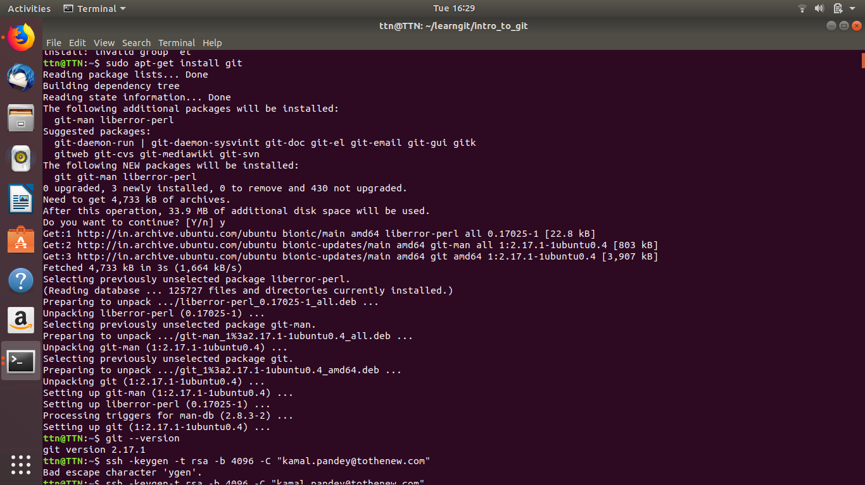

**2: Initialize a Git Repository.**

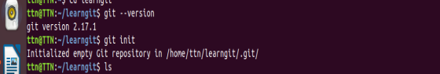

**3: Add files to the repository.**

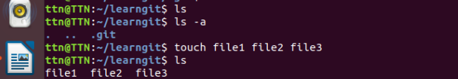

**4: Unstage 1 file.**

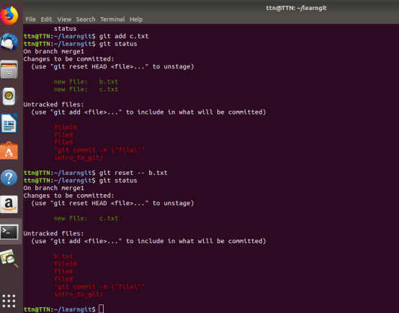

**5: Commit the file.**

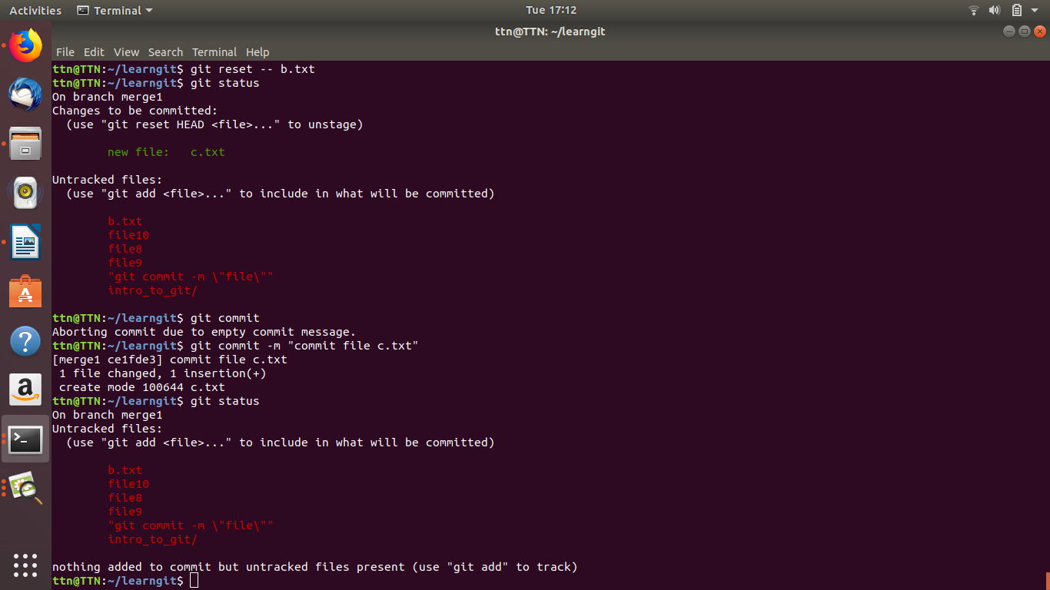

**6: Add a remote.**



**7: Undo changes to a particular file.**

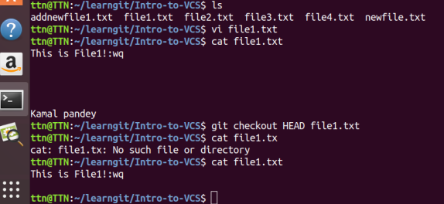

**8: Push changes to Github.**

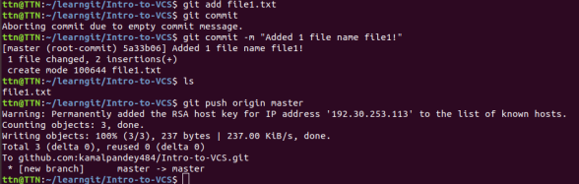

**9: Clone the repository.**

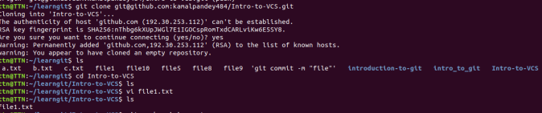

**10: Add changes to one of the copies and pull the changes in the other.**

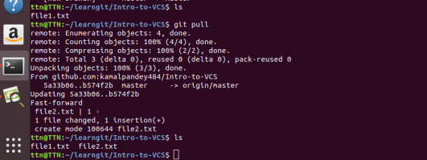

**11: Check differences between a file and its staged version.**

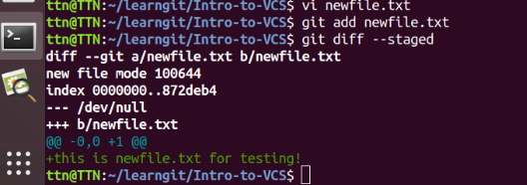

**12: Ignore a few files to be checked in.**

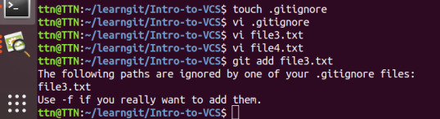

**13: Create a new branch.**

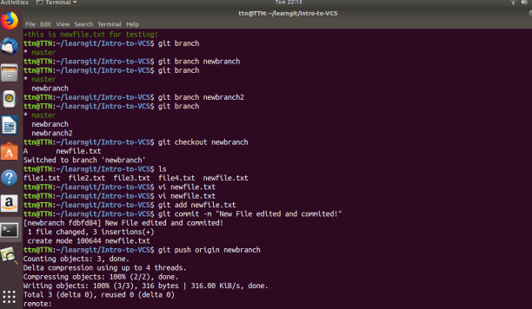

**14: Diverge them with commits.**

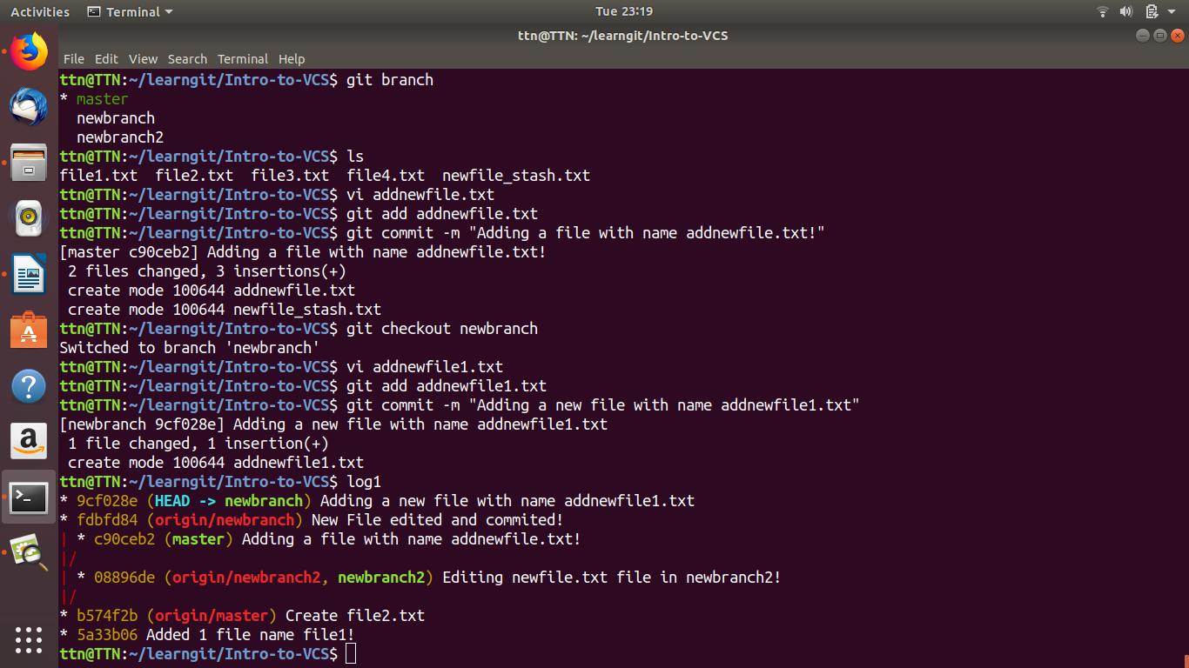

**15: Edit the same file at the same line on both branches and commit.**

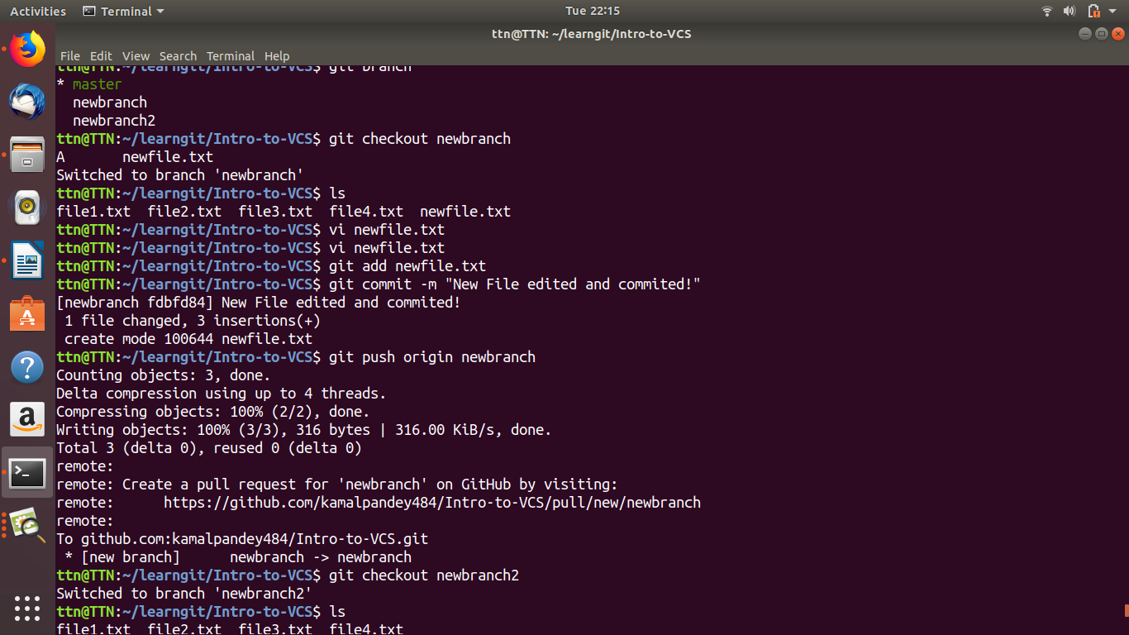

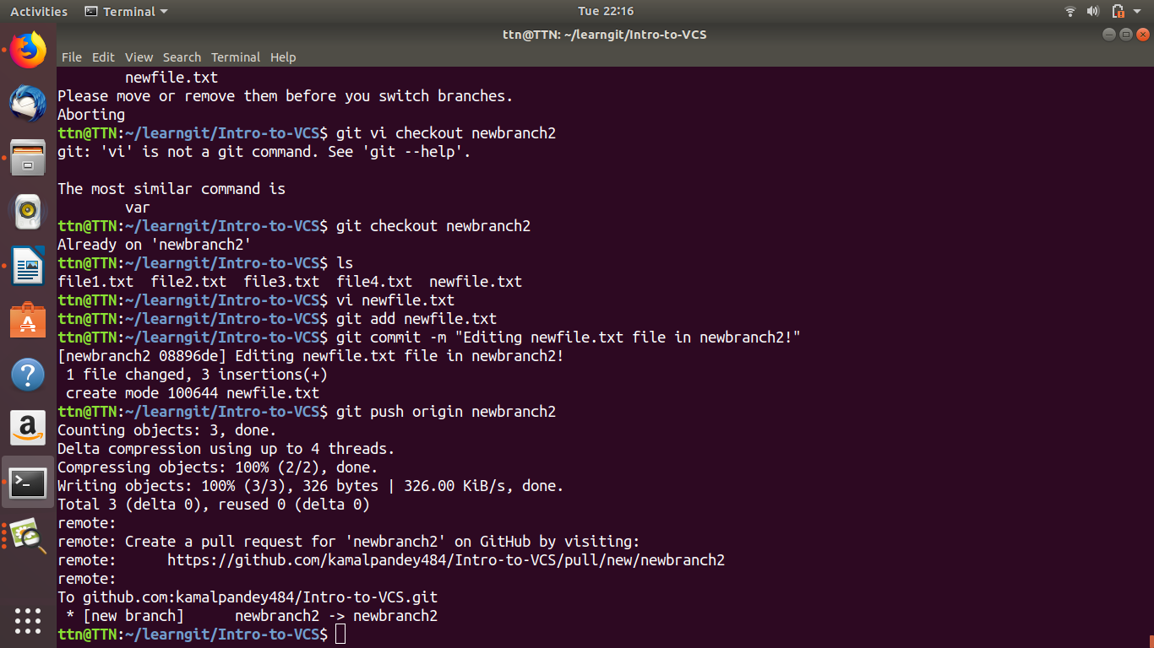

**16: Try merging and resolve merge conflicts.**

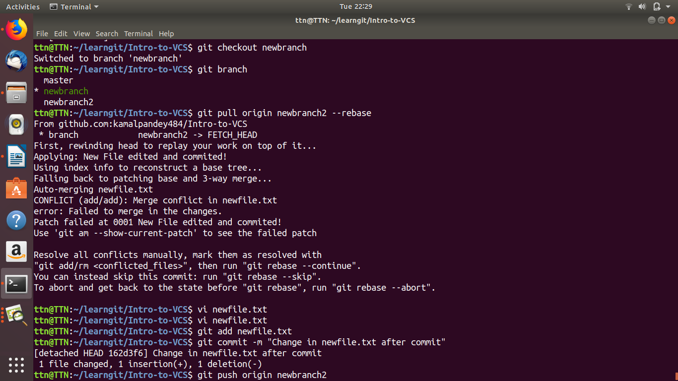

**17: Stash the changes and pop them.**

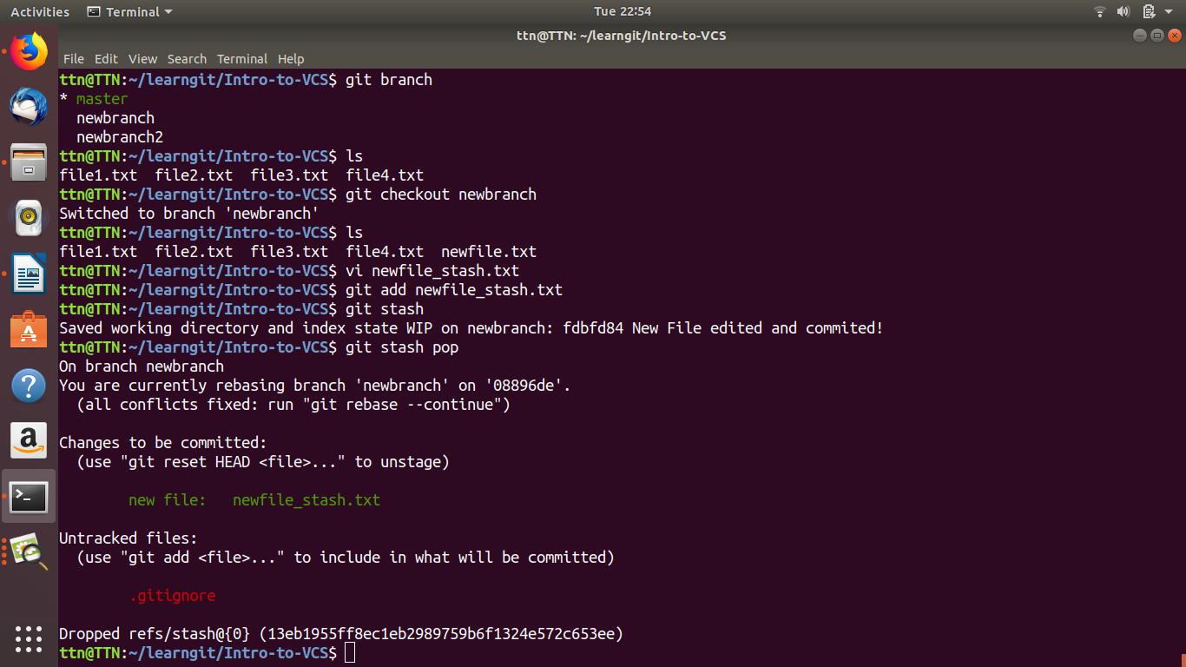

**18: Add the following code to your .bashrc file :**

**color_prompt="yes"**

**parse_git_branch() {**

**git branch 2> /dev/null | sed -e '/^[^*]/d' -e 's/* \(.*\)/(\1)/'**

**}**

**if [ "$color_prompt" = yes ]; then**

**PS1='\u@\h\[\033[00m\]:\[\033[**

**else**

**PS1='\u@\h:\W $(parse_git_branch)\$ '**

**fi**

**unset color_prompt force_color_prompt**

